● Explain Hive Architecture in Brief.

● Explain Hive Components in Brief.

Below diagram shows Hive Architecture and its components..

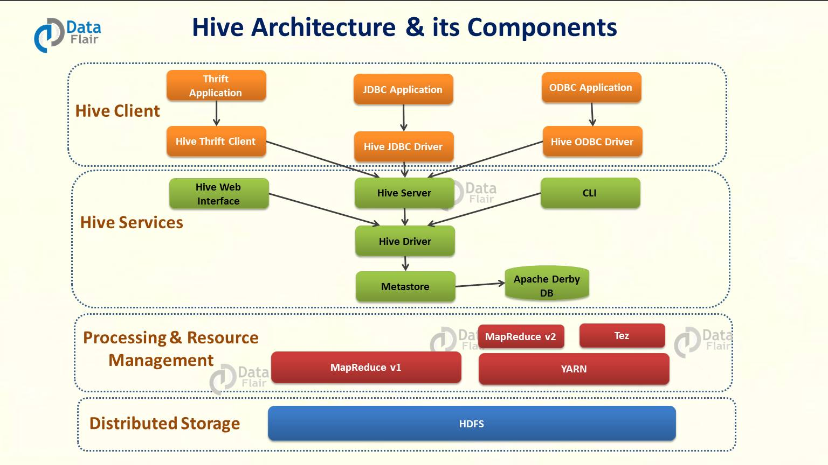

**Hive Client :** Apache hive support all application written in language like c++, Java, Python etc. using JDBC,Thrift and ODBC drivers. Thus one can easily write hive client application written in language at their choice.

Hive support different type of client application for performing queries.

1. Thrift Clients : As Apache Hive Server is based on Thrift , so it can serve the request from all those language that support hive.
2. JDBC clients : Apache Hive allows java applications to connect to it using JDBC drive. It is defined in the class apache.hadoop.hive.jdbc.hivedriver
3. ODBC clients : ODBC driver allows application that supports ODBC protocol to connect to hive.

**Hive Services :** Hive Provides various services like web interfaces, CLI etc. to perform queries.

1. CLI : This is default shell that hive provides, in which you can execute your hive queries and command directly.
2. Web interface : hive also provide web based GUI for executing hive queries and commands .
3. Hive Server : it is built on apache thrift and thus it is also called as Thrift server. It allows different client to submits request to hive and retrieves the final result.
4. Hive Driver: driver is responsible for receiving the queries submitted thrift,JDBC,ODBC,Web interface, CLI by hive client.
   1. Complier : After that hive driver passes the query to the compiler. Where parsing, type checking, and semantic analysis takes place with the help of schema present in the metastore
   2. Optimizer : It generates the optimized logical plan in the form of a DAG (Directed Acyclic Graph) of MapReduce and HDFS tasks.
5. Executor: Once compilation and optimization complete, execution engine executes these tasks in the order of their dependencies using Hadoop.
6. Metastore: it is central repository of apache hive metadata in the hive architecture It stores metadata for hive tables and partitions in a relational database. It provides client access to this information by using metastore service API. Hive metastore consists of two fundamental units:
7. service that provides metastore access to other Apache Hive services.
8. Disk storage for the Hive metadata which is separate from [HDFS](http://data-flair.training/blogs/comprehensive-hdfs-guide-introduction-architecture-data-read-write-tutorial/) storage.

**Processing framework & Resource Management.** : Hive internally uses Hadoop MapReduce framework to execute queries

**Distributed Storage :**As seen above , Hive is built on the top of Hadoop , so it uses the underlying HDFS for distributed storage.